Moment of Inertia
In this experiment, students use a Centripetal Force Apparatus to investigate the moment of inertia for several objects, including a beam, disk, and hoop.

LEARNING OBJECTIVES
- The student will engage in an activity to develop a model based on observations from the physical world.
- The student will explore the effect that moment of inertia has on the angular acceleration of an object about an axis.
- The student will analyze experimental data and compare the data to theoretical models variously shaped objects.

RECOMMENDED GRADES/SUBJECTS
This experiment works well for high school and college students; it can be integrated into physical science, physics, and engineering courses.

TIME ESTIMATE
The project should be able to be completed in one 45-minute period. We recommend that students perform the analysis outside of class. Consider facilitating a 20-minute class discussion the following day to give students time to compare and evaluate their results.

RELATED EXPERIMENTS
Experiment 20 “Centripetal Acceleration on a Turntable” from Physics with Vernier
Experiment 12 “Centripetal Acceleration” from Advanced Physics with Vernier–Mechanics
Experiment 13 “Rotational Dynamics” from Advanced Physics with Vernier–Mechanics
RELEATED NEXT GENERATION SCIENCE STANDARDS (NGSS)
Science and Engineering Practices | Disciplinary Core Ideas | Crosscutting Concepts
Asking questions and defining problems  Analyzing and interpreting data  Using mathematics and computational thinking  Engaging in argument from evidence  Obtaining, evaluating, and communicating information | PS2.A. Forces and Motion | Patterns  Cause and effect  Systems and system models

PRIOR KNOWLEDGE
Students may have previous knowledge regarding how the shape of an object affects its response to a torque. This may be intuitive knowledge (and thereby lacking definition and terminology) or it may be from other experiments, such as those in Physics with Vernier or Advanced Physics with Vernier–Mechanics.
Students are expected to have a familiarity with solving mechanics problems involving rotations and translation.

EQUIPMENT TIPS
The Moment of Inertia Kit (order code: CFA-MIK) includes a variety of mass configurations that attach to both the Go Direct Centripetal Force Apparatus (order code: GDX-CFA) and the Centripetal Force Apparatus (order code: CFA).
The student experiment was written for the Go Direct Centripetal Force Apparatus (GDX-CFA), but the directions can easily be modified to work for the Centripetal Force Apparatus (CFA). Note that if using a CFA, students will need to attach a Vernier Photogate (order code: VPG-BTD) to the CFA to measure angular velocity in the place of Go Direct Force and Acceleration.

LAB PERFORMANCE NOTES
Lab groups may correctly deduce that, all else being equal, the distribution of mass relative to the axis of rotation will affect the angular acceleration of that mass. During the investigation, students make predictions and then gather data.
After data collection, students revisit their predictions and articulate a summary of their pre- and post-experiment impressions. Students calculate the moment of inertia based on their data and identify theoretical moments of inertia for the objects they tested.
Students compare the results of the two approaches (experimental versus theoretical) and are asked to summarize their understanding.
SAMPLE RESULTS AND POST-LAB DISCUSSION
The graph in Figure 1 represents data from all of the mass configurations of the Moment of Inertia Kit and the beam from the Centripetal Force Apparatus. When we were collecting sample data, we started data collection for each trial before releasing the mass. This allowed us to record the initial moments of the movement and minimize the effect of air resistance in our data analysis.

As can be seen in Figure 1, air resistance became particularly evident when the objects were oriented vertically and had a large cross section interacting with the air as they rotated. The slope of the curve tends to flatten, suggesting that the amount of air resistance is affected by velocity.

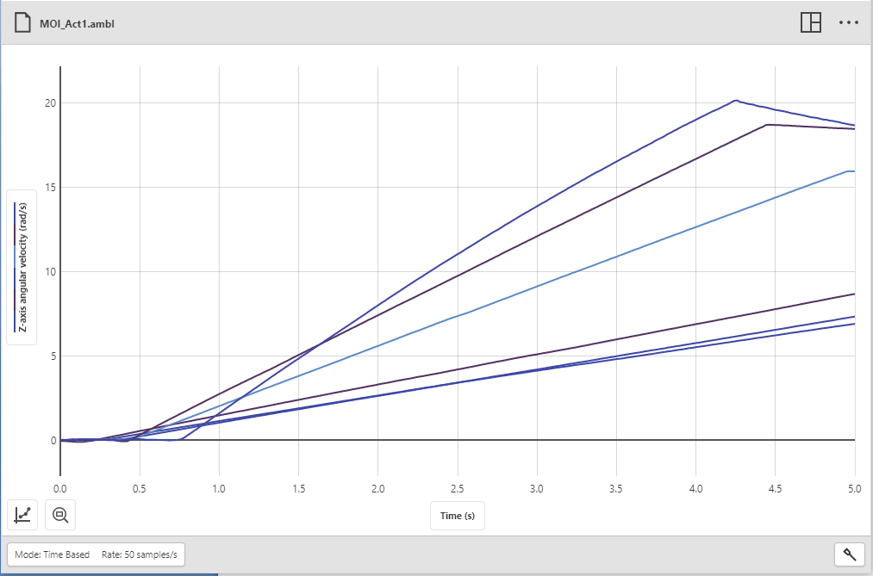
Figure 1

We used the slopes of the angular velocity graphs (Figure 1) to determine the angular acceleration (Table 1).

Table 1
Object | Predicted acceleration ranking  (1 least, 6 most) | Angular acceleration  (rad/s²) | Actual ranking  (1 least, 6 most)
Beam | 4 | 1.62 | 5
Disk (horizontal orientation) | 3 | 3.59 | 3
2 disks | 5 | 1.85 | 4
Disk and hoop | 6 | 1.52 | 6
Disk (vertical orientation) | 1 | 6.56 | 1
Hoop (vertical orientation) | 2 | 4.74 | 2

During analysis, students are expected to reconcile their prediction with the actual data. Student explanations may include the following elements:
- Objects with less mass tend to accelerate more for a given torque.
- Objects with mass positioned closest to the point of rotation tend to accelerate more for a given torque.
Students should determine the tension in the string using Newton’s second law as it applies to the falling mass
mg – T = ma (or T = m(g–a) solving for tension)

and then apply the tension, T, multiplied by the radius of the pulley to determine the torque applied to the system of the rotating mass:
τ = Iα

Dividing the torque by the angular acceleration produces the (experimental) moment of inertia.

Table 2
Object | Moment of inertia–experimental  (kg•m²) | Moment of inertia– theoretical  (kg•m²) | Percent difference  (%)
Beam | 4.38×10^{–03} | 4.10×10^{–03} | 6.7
Disk (horizontal orientation) | 1.97×10^{–03} | 1.76×10^{–03} | 11.8
2 disks | 3.83×10^{–03} | 3.49×10^{–03} | 9.8
Disk and hoop | 4.67×10^{–03} | 4.12×10^{–03} | 13.2
Disk (vertical orientation) | 1.07×10^{–03} | 8.81×10^{–03} | 21.8
Hoop (vertical orientation) | 1.49×10^{–03} | 1.18×10^{–03} | 26.2

To determine theoretical moments of inertia we treated the objects as follows:
- Beam – thin rod rotating about its center: I = (mL²)/12, where L is the entire length of the rod.
- Disk (and two stacked disks) – disk rotating about its center: I = ½ (mR²), where R is the radius of the disk
- Disk and hoop – the sum of the moment of inertia of each of the components individually: disk rotating about its center and hoop rotating about its center. I = ½ mR_{d}² + mR_{h}²
- When oriented vertically, we apply the perpendicular axis theorem: I_{x} + I_{y} = I_{z}, where the x- and y-planes are in the plane of the disk. Symmetry allows us to simplify I_{x} = ½I_{z}.

Students may recognize that the shaft is also rotating and contributing to the overall moment of inertia. We determined the experimental/effective moment of inertia of the shaft to be
1.63×10^{–03} kg•m². If you reduce the experimental moment of inertia by this amount it has a noticeable effect on the values (see Table 3).
Table 3
Object | Moment of inertia–experimental  (kg•m²) | Moment of inertia (removing shaft contribution)  (kg•m²) | Moment of inertia– theoretical  (kg•m²) | Percent difference  (%)
Beam | 4.38×10^{–03} | 4.22×10^{–03} | 4.10×10^{–03} | 2.8
Disk (horizontal orientation) | 1.97×10^{–03} | 1.81×10^{–03} | 1.76×10^{–03} | 2.6
2 disks | 3.83×10^{–03} | 3.67×10^{–03} | 3.49×10^{–03} | 5.1
Disk and hoop | 4.67×10^{–03} | 4.51×10^{–03} | 4.12×10^{–03} | 9.3
Disk (vertical orientation) | 1.07×10^{–03} | 9.11×10^{–03} | 8.81×10^{–03} | 3.4
Hoop (vertical orientation) | 1.49×10^{–03} | 1.33×10^{–03} | 1.18×10^{–03} | 12.4

